**Project Design Phase-II Technology**

|  |
| --- |
| Guidelines:   1. Include all the processes (As an application logic / Technology Block) 2. Provide infrastructural demarcation (Local / Cloud) 3. Indicate external interfaces (third party API’s etc.) 4. Indicate Data Storage components / services 5. Indicate interface to machine learning models (if applicable) |

**Stack (Architecture & Stack)**

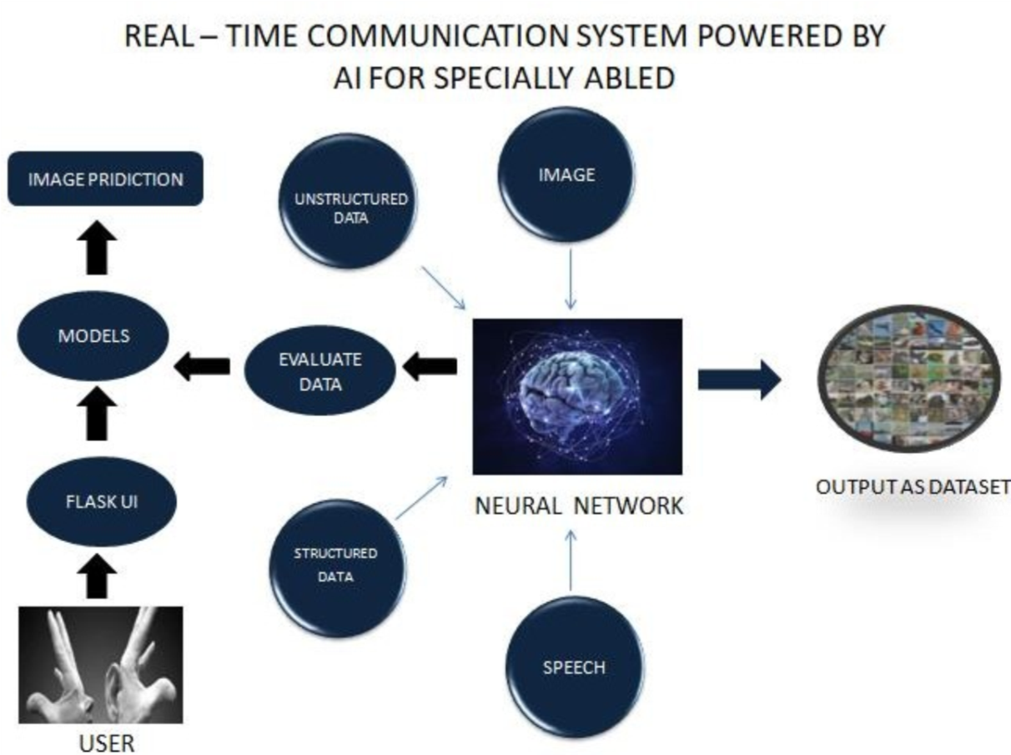

|  |  |
| --- | --- |
| Date | 03-11-2022 |
| Team ID | PNT2022TMID41786 |
| Project Name | Project – Real Time Communication System Powered by AI for Specially Abled |
| Maximum Marks | 4 Marks |

**Technical Architecture:**

The Deliverable shall include the architectural diagram as below and the information as per the table1 & table 2

**Example: Specially Abled person convey their message to others**

**EXAMPLE 2:TECHNOLOGICAL ARCHITECURE**

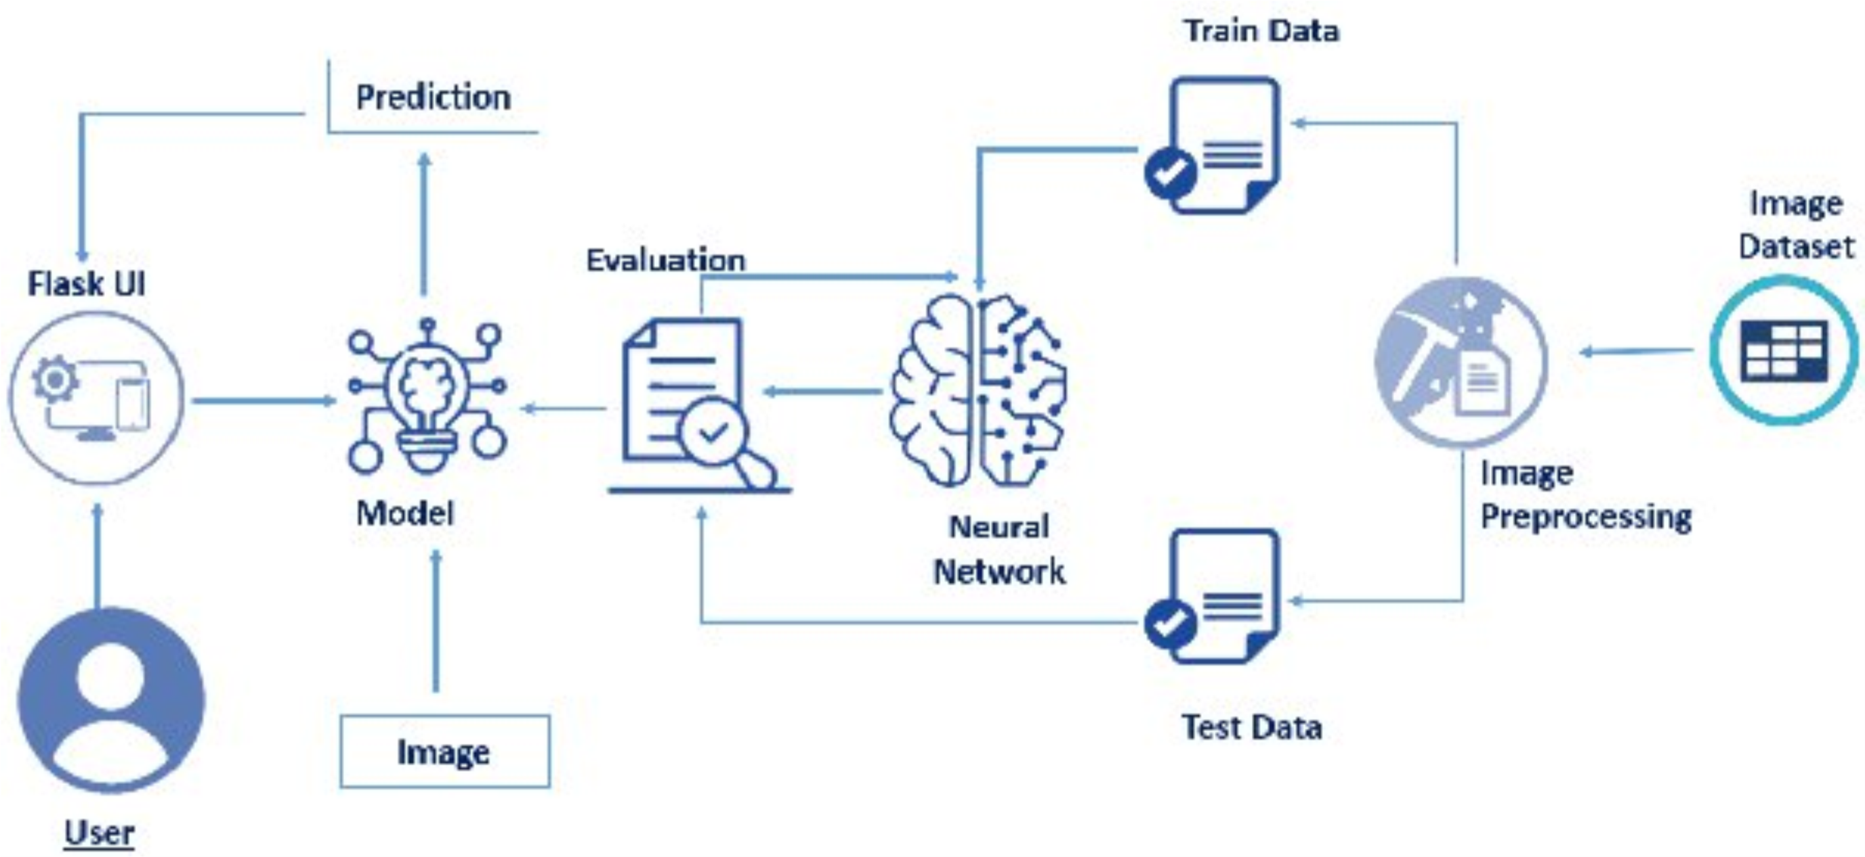

**Table-1 : Components & Technologies:**

|  |  |  |  |
| --- | --- | --- | --- |
| **S.No** | **Component** | **Description** | **Technology** |
| 1. | User | Communication barriers of deaf or hearingimpaired people with other communities, contributing significantly to their social inclusion | AI technology |
| 2. | Flash UI | Flash's user interface components let you interact with the users that use your site and gather information. | Using the cloud it can be executed |
| 3. | Models | Support Vector Machine (SVM) is subsequently applied to classify our gesture image dataset. | Machine Learning |
| 4. | Image Prediction | Gesture can be completely observable and viewing a gesture from another perspective makes the prediction. | ANN,CNN |
| 5. | Image | Image processing is used to made the image into signs by the neural network | ANN, CNN, Open CV |
| 6. | Speech | Speech translates the voice into image and sensitive neural play. | AI and machine learning methods like deep learning and neural networks |
| 7. | Evaluate data | Aims to estimate the generalization accuracy of a model on future (unseen/out-of-sample) data. |  |
| 8. | Unstructured data | P unstructured data is a conglomeration of many varied types of data that are stored in their native formats | Natural Language Processing (NLP) |
| 9. | Structured data | Typically categorized as quantitative data — is highly organized and easily decipherable by machine learning algorithms | Machine language and artificial intelligence tools |
| 10. | Neural network | The same convolutional neural network architecture was used for both, the top view and the bottom view models, the only difference is the number of output units | AI technology |
| 11. | Dataset | First prototype of this system is was used a dataset of 24 static signs from the Panamanian Manual Alphabet. | AI technology |

**Table-2: Application Characteristics:**

|  |  |  |  |
| --- | --- | --- | --- |
| **S.No** | **Characteristics** | **Description** | **Technology** |
| 1. | Open-Source Frameworks | Robots and other tools provide home-based care and other assistance, allowing people with disabilities to live independently | Artificial Intelligence like robots and software systems |
| 2. | Security Implementations | Set the inclusion and exclusion criteria , Report the results in the survey | Artificial Intelligence |
| 3. | Scalable Architecture | The improvement in the specially abled persons interaction with the environments | Artificial Intelligence |
| 4. | Availability | Technology solutions that mimic humans and use logic from playing chess to solving equations and  Machine learning is one of the technologies | Artificial Intelligence |
| 5. | Performance | Enables people with disabilities to step into a world where their difficulties are understood and taken into account | Artificial Intelligence |